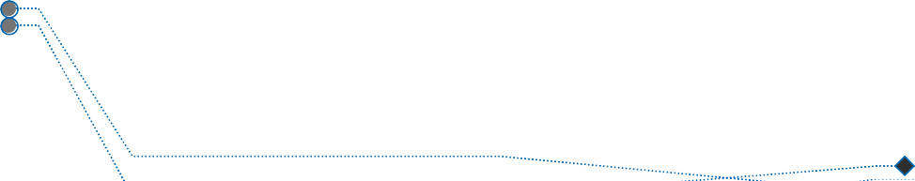
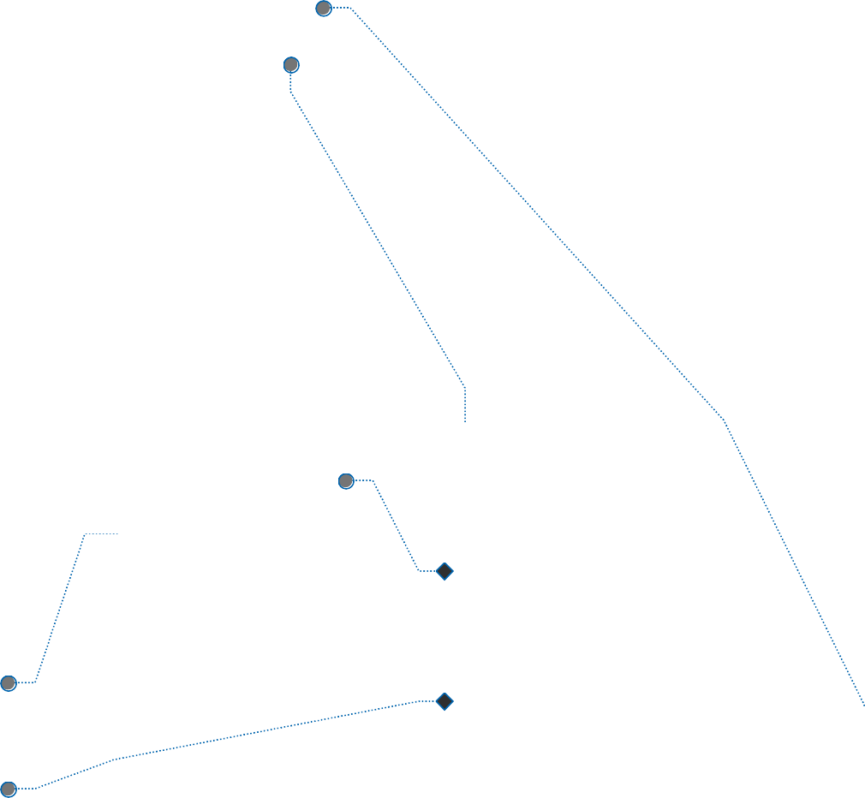
name description category admin_only reporter_points violator_points room_id created_at updated_at deleted_at
id
rules
id
points_log
room_id name created_at updated_at
id
departments
name email age
department position photo points
id
users
rooms
id
name slug
description photo created_by invite_code
invite_code_enabled invite_code_type database_name database_path created_at
updated_at

violations
id
rule_id room_id reporter_id violator_id violator_ids description photos status reject_reason incident_at created_at updated_at

room_id user_id role joined_at created_at updated_at
id
room_members

company_tutorial_completed user_tutorial_completed admin_tutorial_completed email_verified_at
password remember_token created_at updated_at
user_id violation_id points created_at updated_at
job_batches
id
name total_jobs pending_jobs failed_jobs failed_job_ids options cancelled_at created_at
finished_at

jobs
id
queue payload attempts reserved_at available_at
created_at

failed_jobs
id
uuid connection queue payload exception
failed_at
cache
key
value
expiration

cache_locks
key
owner
expiration

migrations
id
migration
batch

password_reset_tokens
email
token
created_at

sessions
id
user_id ip_address user_agent payload
last_activity

